**LAB 07 EXERCISES**

**INSTRUCTIONS**:

**NOTE: Violation of any of the following instructions may lead to the cancellation of your submission.**

1) Create a folder and name it by your student id (k21-1234).

2) Paste the .c file for each question with the names such as Q1.c, Q2.c and so on into that folder.

3) Submit the zipped folder on slate.

**ARRAYS ARE NOT ALLOWED TO BE USED FOR SOLVING THE FOLLOWING EXERCISES.** **DO NOT USE BREAK OR CONTINUE STATEMENTS INSIDE LOOP.**

**QUESTION# 01**

Mark, who is a freshman in BS Computer Science at FAST National University and enrolled in Programming Fundamentals course got confused with a looping scenario, where he had to print his name 10 times, and he was free to choose any of the loops (for, while and do while). He made the program using all of the loops as mentioned below:

|  |  |  |
| --- | --- | --- |
| #include<stdio.h>  main(){  int counter = 0;  while(counter < 10){  printf(“Mark\n”);  counter++;  }  } | #include<stdio.h>  main(){  int counter = 0;  do{  printf(“Mark\n”);  counter++;  }  while(counter<10);  } | #include<stdio.h>  main(){  int counter;  for (counter =0; counter <10;  counter++){  printf(“Mark\n”);  }  } |

After compiling these three you have to report the observations. Furthermore, as a cooperative and helping colleague, you have to suggest mark that which loop is ideal for this scenario and tell him about the other two loops and specify the scenarios also.

**QUESTION# 02**

Jenny Sparks, another fellow of yours made the program for the same scenario. The code is mentioned below. Her, output was stuck in an infinite loop, can you identify the mistake in each of the following solutions and at the end, you need to propose a final solutions which is free of any problems.

**Note: Go for one line answers of each and at the end propose the final solution.**

|  |  |  |
| --- | --- | --- |
| #include<stdio.h>  main(){  int counter;  for (counter =0;;  counter++){  printf(“Mark\n”);  }  } | #include<stdio.h>  main(){  int counter;  for (;;){  printf(“Mark\n”);  }  } | #include<stdio.h>  main(){  int counter;  for (;;counter++){  printf("Mark\n");  }  } |
| #include<stdio.h>  main(){  int counter;  for (;;++counter){  printf("Mark\n");  }  } | #include<stdio.h>  main(){  int counter;  for (counter = -100000000000;counter<10;++counter){  printf("Mark\n");  }  } | #include<stdio.h>  main(){  int counter;  for (counter =0 ;counter>-1;counter *= 2){  printf("Mark\n");  }  } |

**QUESTION# 03**

**This Task especially because you guys are doing BS in Cyber Security.**

In previous lab we had a lab task which was related to cryptography, you have to do this same task using any loop of your choice. Read the modified statement.

**Note: This time don’t use switch statement.**

**Hint:**

**int a = 65;**

**char b = char(a);// in your case if its zero add 65 to it and cast it to character.**

**Now b becomes A.**

Alice and Bob want to exchange the N (Would be asked from user from command line)- digits message on the internet, but they want to ensure the security. They went to a cyber security specialist Edwin for the solution. Edwin listened to the requirement of the clients and proposed a scheme for cryptography, which is first of all the algorithm would reverse the message, after reverting the message, it would determine an alphabetic character against the digit. For example for 0 it would be A, for 1 it would be B, for 2 it would be C, for Z it would be 25.

Write a code in C for the above cryptographic algorithm using loops in C for Edwin.

The samples are like:

|  |  |
| --- | --- |
| Input String | Cypher Text |
| 1546 | GEFB |
| 7777 | HHHH |
| 5555 | FFFF |
| 1234 | EDCB |

**Question # 04**

Anthony, who is a mathematician wants to calculate the square root of the perfect square numbers. For this purpose, he proposed a flowchart and he contacted the Programming Fundamentals to convert the flowchart into computer program. The flowchart proposed by Anthony is provided below, you need to write a neat and clean code to convert this into a code.

**Note: At this stage anyone who includes solution for perfect square may get a bonus point and appreciation.**

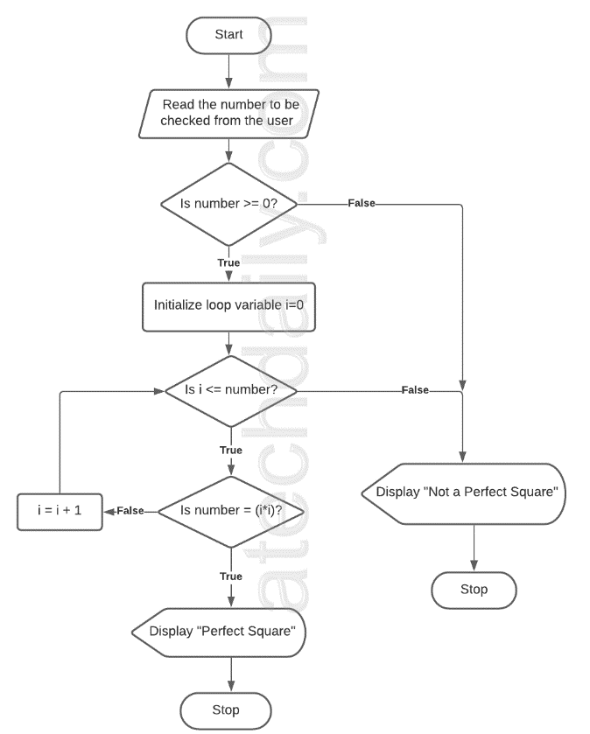

**QUESTION# 05**

**This Task especially because you guys are doing BS in Cyber Security.**

While teaching number theory in Discrete Structures to sophomores, Musawar Ali was explaining the concept of relatively prime numbers, Greatest common Divisors (Euclidian Algorithm to find GCDs) and least common multiples. The students got confused and asked Musawar to provide a C program for this.

In the task below you have to get two numbers as a input from the user, determine the greatest common divisor of the number and least common multiple of the number and determine whether the numbers are relatively prime or not.

**Hint: You do while or while loop.**

**Note:**

Two number are relatively prime if and only if, there is Greatest Common Divisor is 1.

Multiplication of two numbers = gcd * lcm of two numbers.

Pseudo code for the Euclidian algorithm to find greatest common divisor is mentioned below:

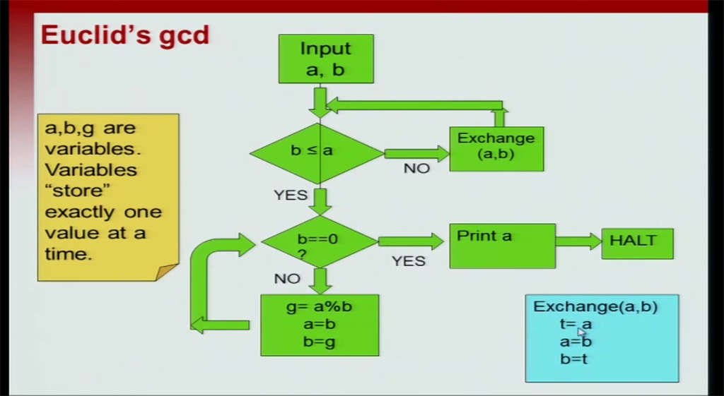

**QUESTION# 06**

**This Task especially because you guys are doing BS in Cyber Security.**

Musawar Ali wants to conduct your quiz online and he wants to randomize the questions out of pool of 100 questions. He wants to randomly pick 10 questions from pool of 100 questions and show on your screen. For this purpose he wants to generate random numbers in the range of 100.One way to generate the random numbers is to use the following equation.

$$x_{n+1}={(a*x}_{n}+c)mod m$$

­

**Note:**

* Here m should be 101 because your range is 100.
* **‘a’** should be first digit of your roll number, if it is 21k9224, then **‘a’** would be 9.
* At the start take $x_{n}$ (usually called as seed) as second digit of your number, here $x_{n}$ would be 2.
* **‘c’** would be third digit of your roll number, here you can take c = 2
* For the next numbers $x_{n}$ would be previously generate random number.

**Samples:**

|  |  |  |
| --- | --- | --- |
| $$x_{n+1}={(a*x}_{n}+c)mod m$$ | $$x_{n+1}=(9*2+2)mod 101$$ | $x_{n+1}=$ 20  This would be $x_{n}$ for next one. |
|  | $$x_{n+1}=(9*20+2)mod 101$$ | $x_{n+1}=$ 81  This would be $x_{n}$ for next one. |
|  | $$x_{n+1}=(9*81+2)mod 101$$ | $x_{n+1}=$ 24  This would be $x_{n}$ for next one. |

**For your ease you may ask value of m (total pool of questions) by user every time and value of the number of questions. Here I need 10 random numbers, so I would print 10 random numbers also.**

**Question # 7**

Judy is trying to design a password verification system, in which there are several constraints which should be applied to verify if a password is valid or not, the constraints are mentioned below:

* This password should be numeric.
* The length of the password should be between 8 to 15.
* Password must have at least 4 odd numbers and 4 even numbers.
* The sum of the password digit must be greater than 10.

You need to write a C program for the above mentioned password verification system.

**Question # 8**

In Programming Fundamentals theory Assignment # 02 Questions # 8, Ms. Sobia Iftikhar asked you to develop a program to convert roman numerals into decimals. For your reference I am attaching the question here also.

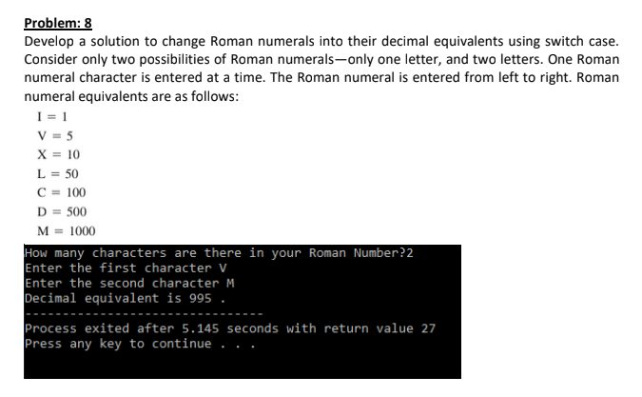

You need to change this task and use loops and the remove limit of the two roman digits, which can be any amount provided by the user. The program should scan the Roman numeral string from user and print the decimal equivalent.

**Question # 9**

Generate the Fibonacci sequence numbers number till less than 500 and compute sum of all the numbers generated by the sequence.

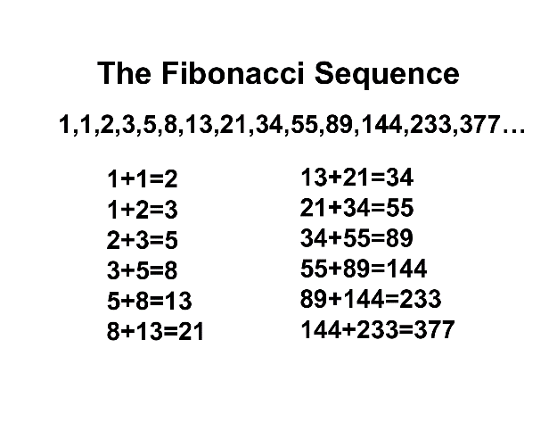

**Question # 10**

This lab may be very much lengthy, but by the end if you solve this by yourself, you would learn something, so don’t get stressed and suggest your friends to also enjoy the life. Whenever you get tired have a cup of coffee, listen to music or go for 10 minutes’ walk. For any queries I am always there for you just email me.

Quote for you guys.

It is harder to read code than to write it.

Joel Spolsky